Team Scrum Coach

**Goal is to work on and reflect on your skills to**

* Communicate effectively in a variety of professional contexts within a team, doing oral or written presentations, and creating technical documents.
* Function effectively as a member/leader of a team engaged in scrums while participating in different roles

**Points:** 20 (see rubric in canvas)

**Deliverables:** Upload this document as pdf or word and location for scrum stand up meeting (Use canvas panopto video to record or to upload the video file) and scrum sprint document containing team sprint information and agenda.

**Due Date:** See canvas.

Scrum Coach

Before you start the GE Sprint

After the GE Sprint

# Scrum Coach

Description: In this role as a coach you get to help lead your team through a sprint. This is focused on you developing skills as a leader and not focusing on trying to be perfect at leading.

**Scrum Coach Expectations**

* Create document and store in your team github repository containing

|  |
| --- |
| Team Scrum GE Sprint Document Containing the following - created by scrum coach  **Title**: GE# and Due Date  **Team Name**:  **Scrum Coach**: Name  **Tech Lead**: Name  **Team Members**: Names  **Scrum Synchronous Stand Up Meeting:** date and time  **Asynchronous team check in schedule:** for example, could be every other day or M-F  **Agenda**: will be added before stand up meeting for GE Sprint by Scrum Coach and updated for issues that arise |

* You will record your meeting but only the part where you are going through the agenda.
  + Should be at most 20 minutes. Use panopto to record or upload video to panopto in the course canvas shell. You will share the link to the video.

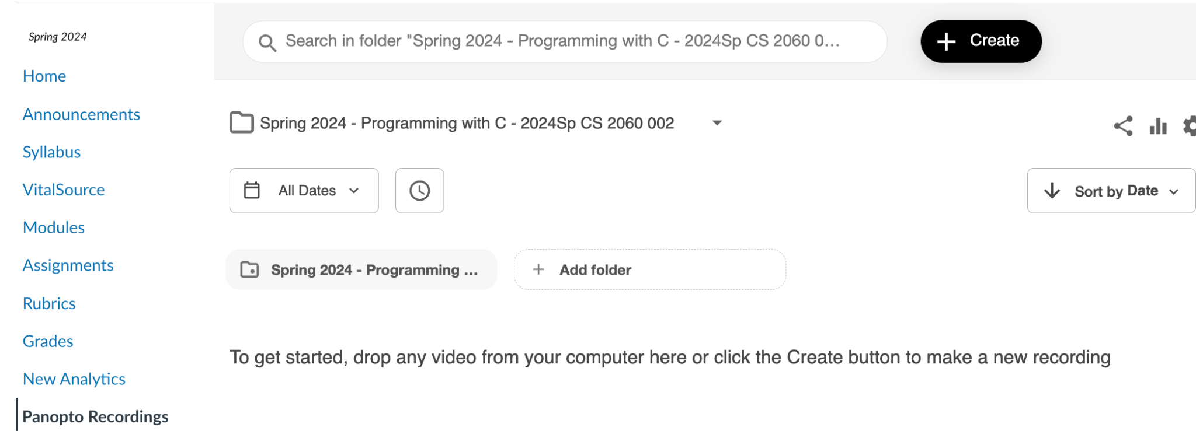

* Update agenda with any items that arise during the asynchronous check ins or synchronous stand up meeting. For example, if an issue arises, the actions to be taken outside the meeting can be listed. Update as status of issue changes.
* Coaches by encouraging collaboration to reach goals and resolve conflicts. This doesn’t mean you are responsible for getting each person to complete the work.
* Communicates through team discord. More communications doesn’t mean more beneficial. Be concise.

**As a team member you should**

* Update the planning board for your tasks
* Contribute to the team technical documentation
* Assist in trouble-shooting issues

**You are not**

* Responsible for getting each person to complete the work.
* Expected to be available to communicate immediately when someone posts a question in the team discord. You should have agreed on how often you will check.

## Before you start the GE Sprint

|  |
| --- |
| Share link to the location of the documentation in your team github repository  <https://github.com/Team-2-1/CS3300-Teams_work/wiki/GE03>  Share a link to your project plan board  <https://github.com/orgs/Team-2-1/projects/2/views/1>  Share Link to team scrum video |

Answer the following in your own words

|  |
| --- |
| Read [What is a Scrum?](https://www.agilealliance.org/glossary/scrum/#q=~) Pick at least two scrum values you want to help your team develop as the scrum lead for this GE sprint. Explain how you plan on fostering those values with the team.   * “Team members solve tough problems & do the right things” * “Respect”   I plan to help foster these values by stressing that people need to do their own work, but ask for help when needed. Additionally, to suggest all respect that we all have lives outside of school |
| Read [The Scrum Coach](https://www.scrum.org/resources/blog/scrum-master-coach-0) What is your focus for this sprint to be an effective scrum coach?  I will focus on pulling and not pushing this sprint. I want all of us to learn and I need to make sure that I only provide what I can, not force others into information or giving when I don’t need to. |
| Read [4 Things to Include in Your Daily Scrum Meeting Agenda](https://hypercontext.com/blog/meetings/what-to-include-in-your-scrum-meeting-agenda) Share at least 3 important takeaways as you prepare your scrum agenda.   * Keep everyone ontime * Make sure people are comfortable by asking for blockers * Goals are important! |
| What is your responsibility to contribute to the team documentation?  My responsibility is to provide any ideas & difficulties I experienced through the sprint in order to help others understand how to dig themselves out a tough issue. |

## After the GE Sprint

|  |
| --- |
| Link to the team technical documentation:  Make sure your name is included with the part of the documentation you created. |
| Summarize in a paragraph your experience being the scrum lead. |
| Reflect on what it was like getting your team to participate in the scrum meeting and in discord. |
| Share 2 of your strengths in this role and one growth area. |
| Share lessons learned that might help the next scrum coach. |
| List each team member and one strength they brought to the team |
| If you have any concerns about your team please share. |